**SYNOPSIS**

**Project Title: Modularity of Mobile Shopping Assistance System**

**ABSTRACT:**

Shopping assistance systems make a great impact on shopping malls revenue, so considering that in mind, Majority of shopping malls has adopted a shopping assistance system that suites to their malls architecture. We a proposing a shopping assistance system framework that can be implemented to any architecture (weather it is based in NFC, QR Code, Barcode, Network or a combination of all). The framework also capable of capturing the new and upcoming mobile technologies.

Guide: Prof Prasad Halgaonkar

**Relevant mathematical models associated with the Project**

Let F be the framework:

Then,

F = {L, O, I, Bm, Cr, Cl, P}

Where, L ,O ,I ,Bm ,Cr ,Cl ,P are the modules of framework

L = Shopping List Management

O = Orientation

Bm = Shopping Basket Management

Cr = Coupon Redemption

Cl = Customer Loyalty Reward

P = Payment

And Let T be the technologies used

Then,

T = {N, B, Qr, Rf, Ir, Nt}

Where,

N = NFC

B = Barcode

Qr = QR Code

Rf = RF Id

Ir = Image Recognition

Nt = Network

Set Theory:

Each module consist of certain set of tasks, and each task uses a specific set of technologies to operate.

For different modules, set of technologies will be,

L = {N, B, Qr, Nt}

O = {Nt}

I = {N, B, Qr, Nt, Ir}

Bm = {N, B, Qr, Rf}

Cr = {N, B, Qr, Nt}

Cl = {N, B, Qr, Nt}

P = {N, B, Qr, Nt}

Data set used in each module is,

L = {Iid, Pr, Nm}

O = {Lid}

I = {Iid|Nm}

Bm = {Iid}

Cr = {Cid,Lid}

Cl = {CuId}

P = {Lid}

Where,

Iid = Item Id

Nm = Item Name

Pr = Item Price

Lid = List Id

Cid = Coupon Id

CuId = Customer Id

**Functions,**

|  |  |
| --- | --- |
| Function | Description |
| getInfo(Iid) => {Iid, Nm, P} | Fetch Info of a Product |
| getCoupon(Lid, Cid) => {P} | Apply Coupon To List |
| getPath(Lid) => {Loc1, Loc2 … LocN} | Get Map For A List |
| getLoyalty(CuId) => {Rank} | Get Loyalty Level Of Customer |
| Payment([CuId, amm] | payId) => {ack} | Send Payment |

**Mapping:**

|  |  |
| --- | --- |
| Function | Mapping |
| getInfo(Iid) => {Iid, Nm, P} | One to one |
| getCoupon(Lid, Cid) => {P} | Many to one |
| getPath(Lid) => {Loc1, Loc2 … LocN} | One to many |
| getLoyalty(CuId) => {Rank} | One to one |
| Payment([CuId, amm] | payId) => {ack} | One to one |

**Venn diagram:**

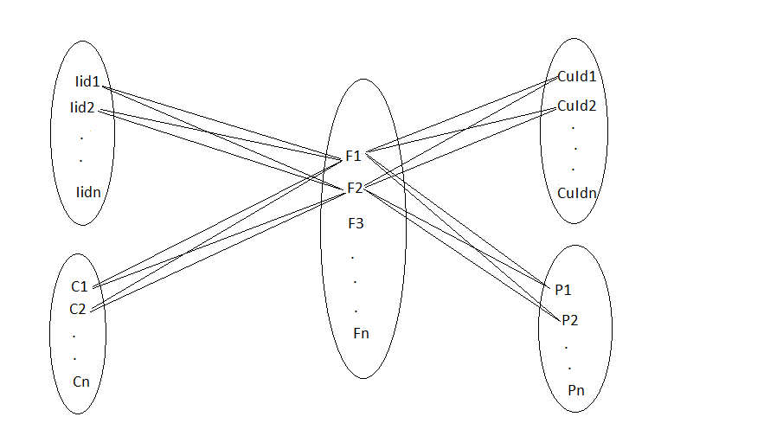

**STATE DIAGRAM**

Diagram 1:

Consider ‘a’ as starting condition, b is state of selection a valid item, c if item is already added to shopping list, d if item is new to the shopping list, e is state of completing adding process, f is state of getting out of shopping list management process.

Success Condition: if user selected a valid item and the item is either new to his shopping list or already added to his list.

Failure condition: If user selected an invalid item.

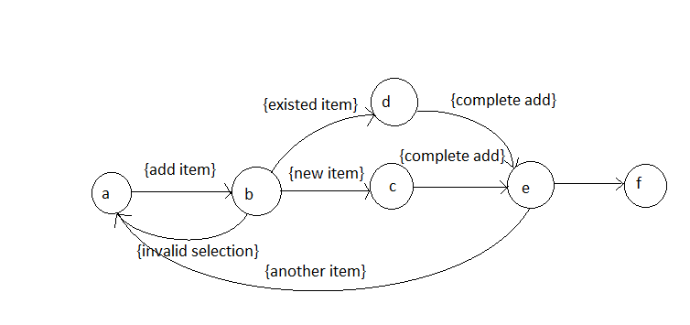

Diagram 2:

Consider ‘a’ is the starting condition, ‘b’ is initialization state where user passes his id and amount to system, c is where the random generated string is encrypted, d is state to send encrypted key to shop, in ‘e’ state shop will decrypt the string, at state f, the decrypted string is matched with the users original string to complete payment.

Success condition:

If original string is matched with shops decrypted key.

Failure Condition:

Either users id is invalid, amount is invalid (i.e. not available in users account) or original string is not matched with shops decrypted key.

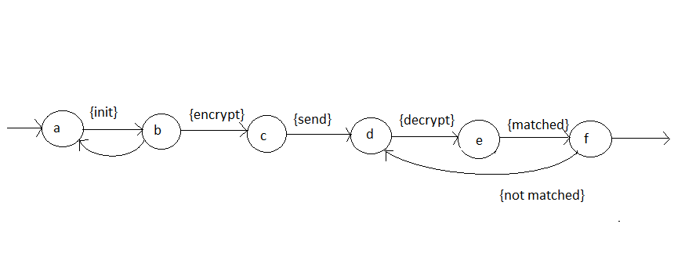

**List of Conference/Journal Papers supporting project idea:**

[1] Modularization of mobile shopping assistance systems by Paradowski, Denise; German Research Center for Artificial Intelligence Campus D3_2, 66123 Saarbrücken, Germany, Kruger, Antonio.

[2] An NFC-Based Solution for Discount and Loyalty Mobile Coupons by Sanchez-Silos, J.J.; Dept. of Computer. & Numerical Anal., Univ. of Cordoba, Cordoba, Spain.

[3] Mobile Near Field Communications (NFC) “Tap ‘n Go” Keep it Secure & Private By Ann Cavoukian, Ph.D. Information and Privacy Commissioner, Ontario, Canada.

[4] Heat of the Moment: Characterizing the Efficacy of Thermal Camera-Based Attacks by Keaton Mowery, Sarah Meiklejohn, Stefan Savage.

[5] Mobile Sales Assistant: An NFC­based product information system for retailers by Stephan Karpischek, Florian Michahelles.

[6] Based on RFID and NFC Technology Retail Chain Supermarket Mobile Checkout by Fugui Ruan, Daijiang Chen.

[7] http://en.wikipedia.org/wiki/A*_search_algorithm

[8] http://en.wikipedia.org/wiki/XOR_cipher

[9] Applying Relay Attacks to Google Wallet by Michael Roland NFC Research Lab Hagenberg University of Applied Sciences Upper Austria

**Plan of project execution**

Figure 5.2.1: Software Development Plan

Project schedule in brief is as shown in the figure.

Milestones are

Group formation, Search and Finalization , Guide allocation

Literature survey, Group discussion basic study

Development of Mathematical moddel and development of UML and project plan

Refinement, Delivery, Documentation

,Feedback

Coding, Testing

, Deployment and presentation of topic at seminars

Deployment

Planning

Modeling

Construction

Communication

Jan

Aug

Oct

Dec

Nov

Sept

July

Feb

Mar

May

1. SRS completed
2. Database schema development
3. Server developed
4. UI completed
5. Alpha testing
6. Beta testing
7. Product deployed

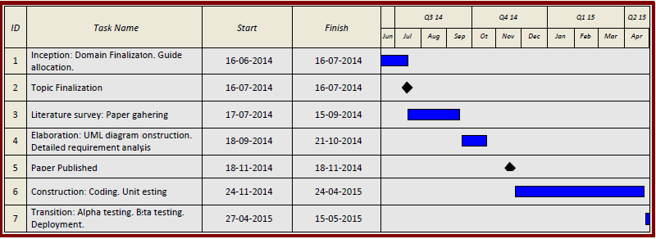

Figure 5.2.2: Gantt chart for Project Development

**Review of submitted paper in last semester**

Reviewers:

Work is appreciable.